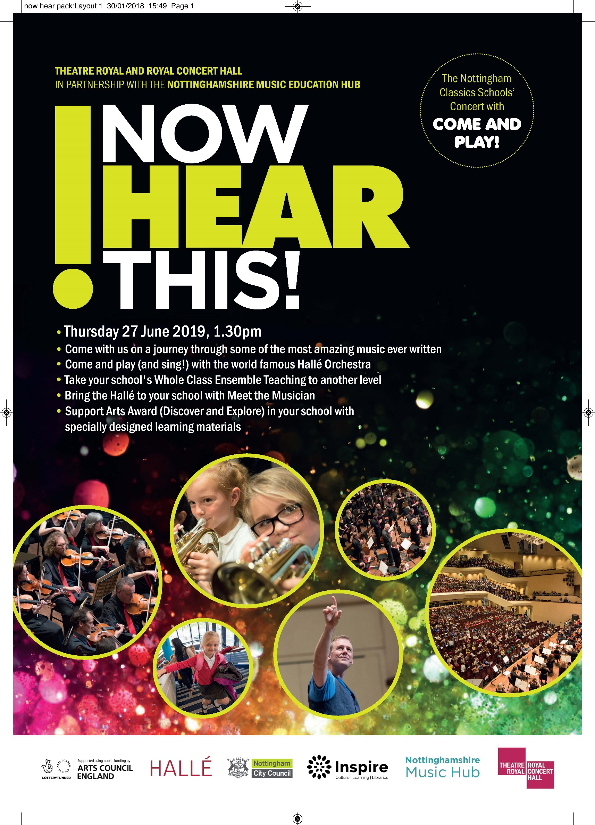

Theatre Royal and Royal Concert Hall in partnership with the
Nottinghamshire Music Education Hub
NOW HEAR THIS! –
Fly me to the Moon!
Thursday 27 June 2019, 1.30 – 2.30pm
(for suggested arrival times, please see the FAQs on p.6)

Featuring music from:

R. Strauss Also Sprach Zarathustra – sunrise
Howard Fly me to the Moon
Holst Jupiter from The Planets
Dvorak Russalka ‘Song to the Moon’
Williams Star Wars: Duel of the Fates
Pickett Three Alien Dances from the Planet Zog
Williams Superman

With the chance to perform with the Hallé in:

J. Strauss II Blue Danube Waltz (Come and Play)
Stanley and Green One Step on the Moon (Come and Sing)
Puente/Pickett Ran Kan Kan (Come and Play)
Pickett/Bennison Galactic Groove (Come and Sing)

Conductor Jonathon Heyward
Presenter Tom Redmond

Now Hear This is a fun-packed, fast-paced introduction to classical music and the instruments of the orchestra for schoolchildren aged 8 to 11, with the chance to join the world famous Hallé in making a sensational sound.

Your guides to the music are conductor Jonathon Heyward and presenter Tom Redmond. This year’s concert celebrates the 50th anniversary of the Apollo moon landing – alien dances and galactic grooves in an hour of space age music to light up the Royal Concert Hall.

The Hallé’s Education Director, Steve Pickett, has arranged Tito Puente’s mambo hit Ran Kan Kan for schools to perform with the Hallé, as well as Johann Strauss’s soaring Blue Danube waltz. Apart from supporting progression routes for young musicians these Come and Play pieces offer an amazing and inspiring experience that they will never forget.

Steve has arranged two songs – Mary Green and Julie Stanley’s One Step on the Moon and a new song, Galactic Groove - for everyone to sing with the Hallé in the concert. To assist with rehearsal in the classroom, the scores, parts and MP3 sound files for the participatory pieces can be downloaded from the Nottinghamshire Music Hub website at www.inspireculture.org.uk/nowhearthis2019

Now Hear This also offers fantastic opportunities to make music come alive before and after the concert. We offer the unique opportunity to Meet the Musician, when a Hallé player visits your school, as well as support materials for students taking the Discover and Explore Arts Awards.
The performance is open to all primary schools from across the city and county.

Read on to find out what’s on offer …
What’s on offer…

1. Come to the concert
Tickets for the concert are just £3. Pupils and Staff will all need tickets.
Each participating school receives a FREE Teacher’s Pack, with learning resources and a CD so that you can get to know the pieces.

Every school gets a chance to perform with the Hallé when we’ll all be singing
One Step on the Moon by Mary Green and Helen Stanley and Galactic Groove by Steve Pickett and Neil Bennison.

To book for the concert (including singing with the Hallé) fill in Form A on page 4.

2. Come and Play Performance
If your school is taking part in Whole Class Ensemble Teaching (WCET) then your instrumentalists can join the Hallé in the performance of Tito Puente’s Ran Kan Kan and Johann Strauss’s Blue Danube Waltz.

NB: Your students must learn the pieces in the period up to 27 June 2019.
It is essential that your instrumental / WCET tutors devote sufficient time to coaching each group. If you require additional support please contact nottsmusichub@inspireculture.org.uk

To book for the Come and Play performance, fill in Form B on page 5.

PLEASE NOTE: If you are bringing both performers and non-performers to the concert please complete both forms (A and B) to book their tickets.

3. Meet the Musician
Schools in the city and county can get to know the Hallé better by meeting one of its players. Hallé players will visit your school in the period leading up to 27 June, lead some creative music work based on the concert and meet your school party at the concert where possible.
A Meet the Musician session will contribute towards your students’ Arts Award journey.

There are 20 Meet the Musician places available. These are FREE but will be allocated on a first come, first served basis. Please make sure that you tick the box at the bottom of your booking form to apply.
Booking Form A: Hallé Performance Only

Use this form for those students and staff who are coming to the concert but who will not be playing a musical instrument in the Come and Play Performance. All schools get to sing with the Hallé.

Please note: If you are also bringing instrumentalists to take part in the Come and Play performance then please also complete Booking form B on Page 5 to book places for those students and staff.

We are a City school County school

We would like to book _____ tickets @ £3 each (staff and pupils) for Now Hear This
on Thursday 27 June at 1.30pm.

Title……….First name……………………….………….Last name…………………………………………………………………

Name of School:……………………………………………………………………………………………………………………………

Postal Address………………………………………………………………………………………………………………………………

……………………………………………………………………………………… Postcode………………………………………………

E-mail address (preferably the music co-ordinator’s) ………………………………………………………………………

Tel. No:……………………………………………………

I enclose a cheque/PO made payable to the ‘Royal Centre’ for £………………………………………

Please charge £……….to my master Card/Visa/Switch Card (please delete as appropriate)

Card Number _ _ _ _ | _ _ _ _ | _ _ _ _ | _ _ _ _ | Expiry Date _ _ | _ _

Issue Number (Switch/Maestro only) _ _ Security number (3-digit number on reverse) _ _ _

Meet the Musician
We would like to meet a Hallé musician

Now return the form, with your payment to: George Matthews, Royal Concert Hall,
Theatre Square, Nottingham NG1 5ND. George.Matthews@nottinghamcity.gov.uk
Your tickets will be sent to your school once we have received payment.

Booking Form B: For schools taking part in the Come and Play Performance

Please note, if your school is also bringing non-instrumentalists to hear the concert then please use Booking form A on Page 4 to book places for those students and staff.

Schools taking part in the Come and Play performance must arrive at the Royal Concert Hall at 11.00am, for the rehearsal at 12.00pm. If you are bringing a mixed party of both performers and non-performers and need to travel together, you should arrive at 12.00pm.

We are a City school County school

Title…..….First name……………………….………….Last name…………………………………………………………………

Name of School:……………………………………………………………………………………………………………………………

Postal Address………………………………………………………………………………………………………………………………

……………………………………………………………………………………… Postcode………………………………………………

E-mail address (preferably the music co-ordinator’s) ……………………………………….………………………………

Tel. No:……………………………………………………

Enter the number of instruments/performers you will be bringing below. All places, including staff,
are £3 each.

- Always use a new line for each different instrument.
- You cannot bring more performers than you actually have instruments for.
- A staff member/supervising adult (they don’t have to play an instrument) must be seated with each group.

e.g.
Instrument ______ violin No. of student players 12 _ No. of staff players _ 2__

Instrument __________________ No. of student players ______ No. of staff players ______

Instrument __________________ No. of student players ______ No. of staff players ______

Instrument __________________ No. of student players ______ No. of staff players ______

Instrument __________________ No. of student players ______ No. of staff players ______

Instrument __________________ No. of student players ______ No. of staff players ______

Total No. of student players ______ Total No. of staff ______

If you need to add extra players, please print this form twice and attach both copies together.

I enclose a cheque/PO made payable to the ‘Royal Centre’ for £……………… (total no. of places x £3)
Please charge £……….to my master Card/Visa/Switch Card (please delete as appropriate)

Card Number _ _ _ _ | _ _ _ _ | _ _ _ _ | _ _ _ _ | Expiry Date _ _ | _ _

Start Date _ _ | _ _ Security number (3-digit number on reverse) _ _ _

Meet the Musician
We would like to meet a Hallé musician

Now return the form, with your payment to: George Matthews, Royal Concert Hall,
Theatre Square, Nottingham NG1 5ND. George.Matthews@nottinghamcity.gov.uk
Your tickets will be sent to your school once we have received payment.

Frequently Asked Questions:

- Do we have to pay for tickets for teachers as well? Yes, everyone who will be attending the performance will need their own ticket.

- When will we be able to download learning materials for the concert ?
You can download these now from www.inspireculture.org.uk/nowhearthis2019
You will also receive CDs featuring all of the music in the concert when we post your tickets to you.
- When will The Hallé contact us about Meet the Musician?
The Hallé will contact schools who have chosen Meet the Musician shortly after we have received your booking form. This will be a two-hour classroom-based session about one of the pieces in the Now Hear This programme. The Hallé will tell you what to expect from the school visit and what you need to do to prepare.

- Do we need to send payment with the booking form, or can payment be made later?
Your should send payment with your booking form or request an invoice, which will be sent soon after we receive your booking. Tickets will only be sent when your payment has been processed.

- Does the Royal Concert Hall have a risk assessment for the event we can download?
Yes, please go to trch.co.uk/creativelearning/information-for-school-visits/ for all information about bringing a school group to the Royal Concert Hall.

- What is the policy for taking photos/filming on the day? You are only allowed to take photographs/record your own group/school. You can take photos/film in the Hall from behind if no individuals from other schools are identifiable. You can take photos of the Hallé (without a flash), but no filming of the musicians please.

- What time do we need to arrive? If you are bringing instruments for the Come and Play performance, you need to be in the Hall and ready to play in the rehearsal at 12pm, so your should arrive at 11am.
If you are just coming for the concert and to sing, you will need to be in the Hall and in your seats for the start at 1.30pm, so please arrive at 12.30pm.

- What time should we arrange for the buses and coaches to collect us? The Concert will finish at around 2.30pm and it can take up to 30 minutes to get your group out of the building.

- When will the Arts Award support materials be available? The Discover / Explore Arts Award materials will be available from the Nottinghamshire Music Hub, nottsmusichub@inspireculture.org.uk from 25 February 2019.

