The Gallery at West Bridgford Library
Information for hire applicants

Introduction

The gallery is located on the ground floor of West Bridgford Library. The purpose-designed gallery provides a modern, professional and light space for exhibitions, and aims to:

- provide a space for people to enjoy the library service’s own programme of exhibitions, including touring and collaborative exhibitions – with the aim of bringing great art to everyone at the heart of the community.
- provide opportunities for artists to hire a professional gallery space outside of our programmed, exhibitions, to support artists in reaching a wide and varied audience with their work.
- raise the profile of West Bridgford Library as a place for quality art, which is supportive of visual arts.
- encourage new and existing audiences to engage with art.

The space

The gallery area has a total of approx. 17.5 linear metres of hanging wall space, fitted with an HTrack hanging system for the hanging of double strung 2D work.

The gallery also has a glass cabinet for displaying work, which has the following dimensions: 1800mm high x 820mm wide x 410mm deep. Shelves can be removed, to make space for taller work.

A number of plinths are also available, three at 120cms tall and two at 90cms tall. The plinth tops are all 30cm-30cm. Work cannot be secured to the plinths, so these are generally used for guest books, leaflets and business cards.

A floor plan of the gallery space is contained at the end of these guidelines.

Hiring the gallery

The gallery is available for hire by application in periods not taken up by the exhibition programme.

Hiring artists benefit from:
- a professional, modern gallery space.
- the opportunity to reach a wide audience thanks to the library’s high daily footfall.
- seven days a week opening
- opportunities for promotion (where available)
- opportunities to engage with audiences through planned talks/workshops (at the approval of, and in liaison with, the library manager, additional room hire charges may apply).

The gallery area also hosts events in the library’s year-round programme, including weekly children’s activities. These events bring audiences into the library and provide opportunities for new audiences to engage with art works on display, including hirers’ exhibitions.

The gallery is available to hire in periods of three or six weeks. Fees for hire of the gallery are as follows:

Six weeks gallery hire
Commercial artists/organisations: £220
Non-profit artists/organisations: £100

Three weeks gallery hire
Commercial artists/organisations: £120
Non-profit artists/organisations: £60

Hire is by application, and application forms can be found on the website (www.Inspireculture.org.uk) or are available from the library.

We aim to provide a programme of quality exhibitions, and applications are considered 4 times a year by a panel and selected in terms of appropriateness for the venue, availability, and contribution to a varied exhibition calendar.

We are keen to see hirers’ proposals for talks/workshops during the period of their exhibition, to help engage audiences with the work on display. (Additional room hire charges may apply).

Important information for artists hiring the gallery

- Hirers must accept and abide by the Terms and Conditions of library gallery hire, available on the library web pages or from the library.
- Hirers should have Public Liability Insurance in place of at least £5 million to cover the period of hire and provide evidence of this to the library.
- Exhibitions are entirely at the hirer’s risk, and insurance of works is the hirer’s responsibility.
- Work should be hung using the gallery’s hanging system and accessories provided, and no fixtures or fittings should be fixed to the gallery walls. Work should be double strung.
- Hirers should not bring in any additional furniture or display freestanding work that is too large for our glass cabinet.
- Hirers will be responsible for hanging their own exhibitions. Advice can be provided by the library manager.
- Work should be clearly labelled; either on the work itself or on labels mounted to foam board and attached using Ryman Command Poster strips (hirer’s own responsibility). Alternative labelling requires the approval of the Inspire Arts Team.
- Hirers should make themselves aware of events taking place in the gallery during their exhibition period by contacting the library. Some of these may mean that access to the gallery is restricted for short periods of time.

Floor Plan

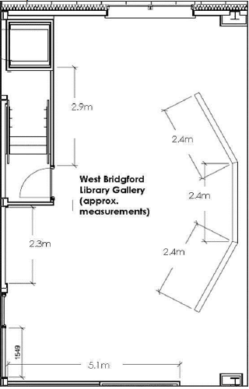

Contact
For further information, in the first instance, contact the library at
westbridgford.library@inspireculture.org.uk or call 0115 981 6506

