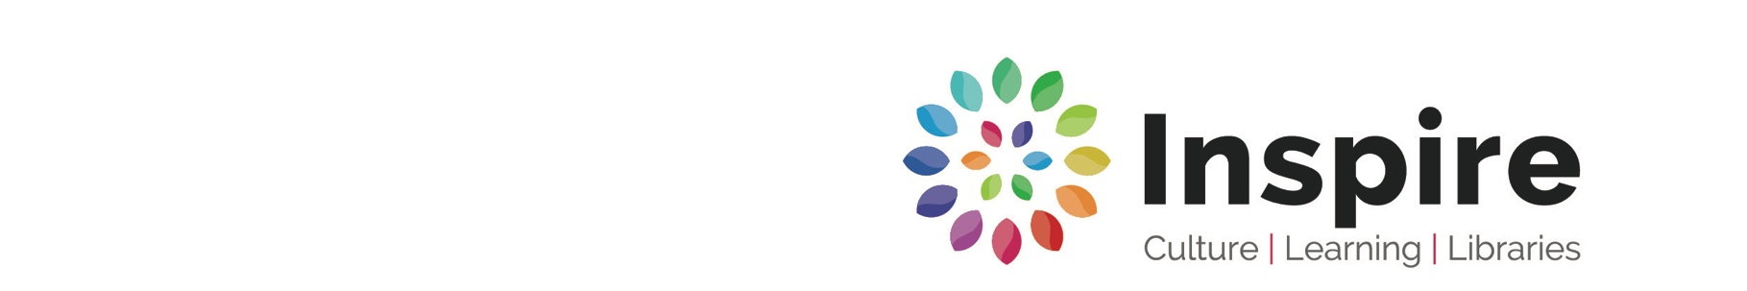

Public Behaviour in Libraries and Archives buildings: Acceptable Use Policy

- Inspire Libraries, Learning and Archives services have an important role in maintaining and developing collections of books, archives, audio visual and technology networks which enable people to pursue learning opportunities and social, cultural and recreational activities.

- This acceptable use policy sets out the terms between you and us in respect of the behaviour that is expected by the public in both their use of the service and their dealings with the staff.

- By using computers in the library, you also agree to abide by the Internet Acceptable Use Policy statement for our Newlinc computer services or using our free Wifi service.

- Our staff* have a right to expect reasonable behaviour on the part of users and a responsibility to ensure that inappropriate behaviour is dealt with. In addressing any matters relating to the above, they will be supported by library management.

- Behaviour which will be seen as contravening acceptable use will include, but not be strictly limited to, the following:

- behaving in a disorderly manner in the building;
- wearing inappropriate levels of clothing
- shouting at, or using obscene, threatening or abusive language towards either staff or other members of the public;
- taking any actions that are likely to cause injury to the staff, other members of the public or Inspire property;
- intentionally or recklessly obstructing any member of the staff carrying out their duties;
- intentionally disturbing, obstructing, interrupting, abusing or annoying any other member of the public who is properly using the service;
- using your or our computer equipment in our buildings to access inappropriate material including but not limited to that which is defamatory, libellous, obscene, indecent, pornographic, discriminatory or any illegal activity;
- consuming alcohol on the premises and/or behaving in an intoxicated manner
- subjecting a member of staff or another member of the public to unwanted and unsolicited personal attention in any form;
- intentionally seeking to display, distribute, or leave any bill, placard, notice or other document in the library without the consent of an appropriate manager;
- seeking to enter the building / use library services if banned from doing so either by Inspire, or a law enforcing body (eg the police);
- undertaking any activity that is in contravention of the law, this includes but is not strictly limited to taking and/or dealing controlled drugs as defined by Schedule 2 of the Misuse of Drugs Act
- undertaking any activity with the intention to draw customers using Inspire services into terrorism as defined in section 26 of the Counter-Terrorism and Security Act 2015
- undertaking any activity which is in contravention of the code of conduct relating to both the Archives and Inspire Learning.

- The above is enforceable through library byelaws with the following being the most relevant:

- Byelaw no.9 – no persons shall behave in a disorderly manner in the library, use violent, abusive or obscene language therein, or intentionally or recklessly cause or do anything likely to cause injury to any other person or property.

- Byelaw no. 13 – no person shall intentionally or recklessly obstruct any library officer in the execution of his duty, or intentionally or recklessly disturb, obstruct, interrupt, abuse or annoy any other person properly using the library.

- Byelaw no. 14 – no person shall, without the consent of a library officer, intentionally display, distribute, or leave any bill, placard, notice or other document in the library

- Byelaw no. 18 – no person in any part of the library shall inhale any toxic substance for the purpose of causing intoxication, or take any controlled drugs as defined by Schedule 2 of the Misuse of Drugs Act other than drugs dispensed for and pursuant to prescription issued for him by a doctor under and in accordance with the aforesaid act

- Byelaw no. 19 – no person shall, except with the consent of a library officer, partake of refreshment in the library

- In the event of this policy being contravened local management will decide upon the appropriate action to be taken against the offender. This will generally be a verbal or written warning or a ban dependent upon the seriousness of the transgression.

*Throughout this document the word “staff” includes volunteers as well as people who are contractually employed by Inspire

Reviewed May 2019

