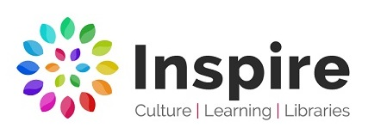

Artist and Author in Residence Brief – Summer Reading Challenge 2021

Who we are:
Inspire: Culture, Learning and Libraries is a charitable community benefit society delivering cultural and learning services across Nottinghamshire.

Our mission is: “To inspire people to read, learn and enjoy culture”.

www.inspireculture.org.uk

What we want:
We are looking for a creatively curious visual artist and an author/writer who get excited about a blank page, like to think imaginatively and enjoy sparking off other people.

The Artist and Author in Residence will:
- Take wide inspiration from the Summer Reading Challenge 2021
- Design and deliver a creative project that engage children and families
- Work collaboratively with Inspire and each other
- Engage school communities and libraries in art and reading

Our aims are to:
- Engage children and families with the Summer Reading Challenge theme
- Make great artwork
- Create great stories

Our outcomes are to:
- Connect with one or more schools
- Connect with Inspire Libraries
- Create a physical and online exhibition
- Leave a legacy

Further information

The Summer Reading Challenge
Every year, thousands of families all over the country take part in the UK’s biggest reading event for children in libraries and online, produced by the charity The Reading Agency. www.readingagency.org.uk

The challenge, aimed at children aged 4 – 11, encourages them to read books of their choice from their library during the summer holidays in order to sustain reading ability and enthusiasm for reading for pleasure in the long summer break.

The Summer Reading Challenge 2021 theme is Wild World Heroes, a celebration of nature and action for the environment that will seek to show children how they can make a difference in the world. Developed in partnership with WWF UK–the world’s leading independent conservation organisation.

Past Artist and Author projects
To see examples of how previous artists and authors have approached the project in the past, visit our website, but we are always looking for new ideas and approaches.
www.inspireculture.org.uk/artistandauthor

The exhibition
The Summer Reading Challenge 2021 Exhibition will take place in West Bridgford Library Gallery. www.inspireculture.org.uk/galleries

Delivery timeline
April 2021 – September 2021

Fee
Minimum £4000 per person. A breakdown of the total fee will be negotiated once the final delivery method and approach is agreed. Additional budget for travel, materials, access costs and to ensure quality outcome for the exhibition is available.

Our rates of pay for guidance:
£135 prep day rate
£200 delivery day rate

Applications process
Submissions should be made by 9am on 1 February 2021 to arts@inspireculture.org.uk

We encourage either individual or joint applications and are happy to hear from writer illustrators.

What we need from you:
Your creative response! Tell us how you will use your talents to meet the aims. These are some prompts to help you think about what you might do.
- What is your process?
- How will you deliver it?
- What will you need?
- How will it look?
- How will it engage our audience?
- What will it leave behind?

We want to work with new and/or established artists but would like to see some examples of your work that will help us know more about your practice. This might be:
- Weblinks
- Photos
- Social Media account links
- Book titles
- Podcasts
- Something else…?

We will accept any form of application:
- Written (Max one side of A4)
- Audio (Max 2 mins)
- Drawn (Max A2)
- Filmed (Max 2 mins)
- Something else…?

And finally
Inspire is a National Portfolio Organisation (NPO) and this opportunity is funded by Arts Council England.

Inspire’s NPO funding focuses on the following Libraries:
Arnold, Beeston, Bingham, Hucknall, Kirkby in Ashfield, Mansfield, Newark, Retford, Southwell, Sutton in Ashfield, West Bridgford and Worksop

We are committed to attracting and recruiting diverse candidates and welcome applications from underrepresented groups.

Thank you for taking the time to review this brief.

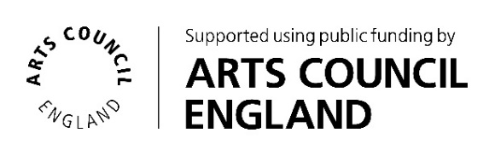
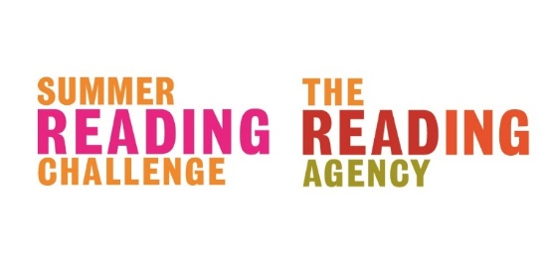
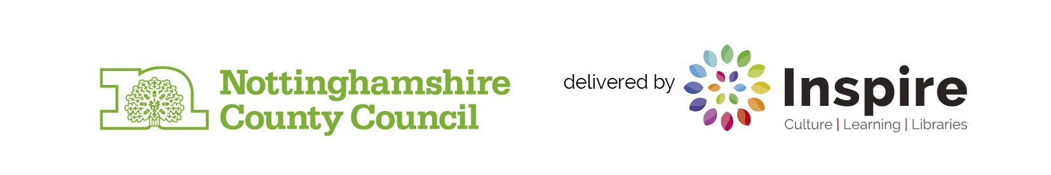
If you require Inspire to make any reasonable adjustments to the process of receiving your ideas and make it more accessible for you, please contact: arts@inspireculture.org.uk

