

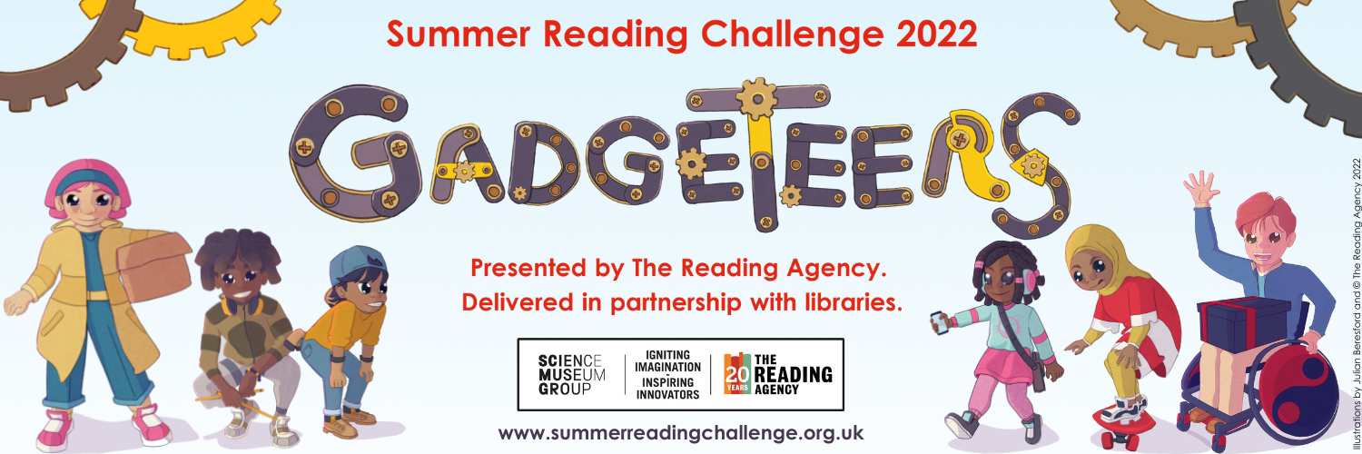**Suggested text for school websites / newsletters**

**Gadgeteers, Summer Reading Challenge 2022 at Inspire libraries  
9 July - 4 September**

Libraries in Nottinghamshire are gearing up for a summer of reading, as the Summer Reading Challenge returns with a special science and innovation themed challenge.

Produced by The Reading Agency and run in libraries across the country the Summer Reading Challenge is a brilliant way to maintain children’s reading enthusiasm throughout the summer break.

Children read six library books of their choice over the summer, collecting rewards (including smelly stickers) along the way. Every child who completes the challenge will receive a certificate and medal.

This year children are invited to join the Gadgeteers on a science filled reading adventure.

Gadgeteers is running in all Inspire libraries until Sunday 4 September. For children aged 4 – 11. It’s completely FREE to take part.

Developed in partnership with the Science Museum Group. Gadgeteers will be a celebration of reading, imagination and science.

Find out more at [www.inspireculture.org.uk/summerreadingchallenge](http://www.inspireculture.org.uk/summerreadingchallenge)

**Gadgeteers, Summer Reading Challenge 2022 at Inspire libraries  
9 July - 4 September**

Libraries in Nottinghamshire are gearing up for a summer of reading, as the Summer Reading Challenge returns with a special science and innovation themed challenge.

Produced by The Reading Agency and run in libraries across the country the Summer Reading Challenge is a brilliant way to maintain children’s reading enthusiasm throughout the summer break.

Children read six library books of their choice over the summer, collecting rewards (including smelly stickers) along the way. Every child who completes the challenge will receive a certificate and medal.

This year children are invited to join the Gadgeteers on a science filled reading adventure. As children progress through the challenge they will discover the innovative ways the Gadgeteers are preparing for a party at their local community centre. Exploring the science and innovation behind everyday objects along the way.

Children sign up at the library to pick up a collector poster then read six library books, collecting rewards (including smelly stickers) as they progress. Every child who completes the challenge will receive a certificate and medal.

Children choose the books they want to read; story books, fact books, poetry, joke books –all reading counts!

Gadgeteers is running in all Inspire libraries until Sunday 4 September. For children aged 4 – 11. It’s completely FREE to take part.

Developed in partnership with the Science Museum Group. Gadgeteers will be a celebration of reading, imagination and science.

Find out more at [www.inspireculture.org.uk/summerreadingchallenge](http://www.inspireculture.org.uk/summerreadingchallenge)