

**Early Years and Visual Arts Development Commission –**

**Early Years Consultants**

**Who we are:**

Inspire: Culture, Learning and Libraries is a charitable community benefit society delivering cultural and learning services across Nottinghamshire.

Our mission is: “To inspire people to read, learn and enjoy culture”.

**[www.inspireculture.org.uk](https://www.inspireculture.org.uk/)**

Our full charitable objects can be found here: [**About Us | Inspire - Culture, Learning, Libraries (inspireculture.org.uk)**](https://www.inspireculture.org.uk/about-us/)

Inspire is a National Portfolio Organisation (NPO) and this opportunity is funded by Arts Council England.

**The story of Little Creatives**

Inspire secured Arts Council funding to develop early years visual arts. In 2018 early years specialist consultants were commissioned to train a team of five artists. The artists worked to adapt their arts practice to be suitable for the early years. They went on to deliver workshops in early years settings and libraries with families to test and improve the offer as a piece of action research.

A programme of [**Little Creatives**](https://www.inspireculture.org.uk/arts-culture/community/little-creatives/)workshops for children aged from 2 -5 resulted and the team have been working creatively to help early years' children learn new skills and have multi-sensory creative experiences since.

The current Little Creatives workshop programme ended in March 2023.

**What we want:**

We are looking for **early years expert(s)** to devise a training/mentoring programme for five visual artists. The programme will inform them about early years approaches and educational development. It will enable the artists to develop their individual practice so they can deliver creative visual art workshops for the early years. The training will:

* Be based on the best practice and ethos of early years education
* Explore the early years’ curriculum and its relationship with the creative process
* Explore strategies and skills for engaging very young children and their families
* Explore physical and learning developmental milestones and identify activities that will help children achieve them
* Stimulate creativity
* Provide feedback and mentoring at explorative artist led workshop sessions with groups

The training programme will ideally be in **September 2023** and can be a combination of in person and online sessions. In person activity will take place in library settingsin different Nottinghamshire districts, to be decided. For information our libraries are listed here: [**Our Libraries | Inspire - Culture, Learning, Libraries (inspireculture.org.uk)**](https://www.inspireculture.org.uk/reading-information/find-a-library/)

**Fee Available**

1. Early Years practitioners/consultants fee to create and deliver the training and mentoring programme

**Total**  **£6000**

**To express an interest in early years consultancy role please provide:**

1. An outline proposal of how you might approach the training and mentoring offer to artists. Please include an observation and delivery feedback for each artist at an explorative workshop session (or an alternative mini teach observation /mentor session). All dates for sessions to be agreed.
2. Supply credentials in the form of past work, web links and references.

**Timeline for applications**

Submissions should be made by **9am** on **Monday 12 June 2023** to [**arts@inspireculture.org.uk**](mailto:arts@inspireculture.org.uk)

Training will ideally be in **September 2023.**

The artist led explorative workshop sessions will follow the main training programme.

**And finally**

We are committed to attracting and recruiting diverse candidates and welcome applications from underrepresented groups.

If you require Inspire to make any reasonable adjustments to the process of receiving your ideas and make it more accessible for you, please contact: [arts@inspireculture.org.uk](mailto:arts@inspireculture.org.uk)

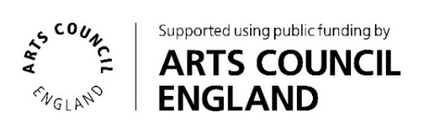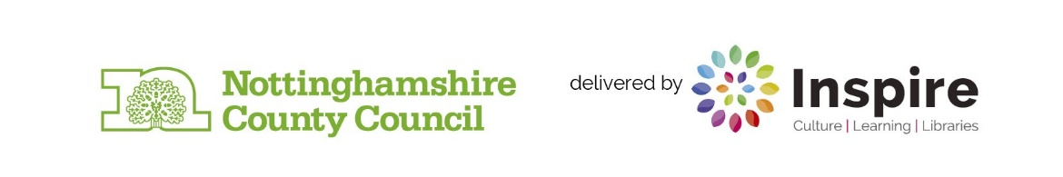Thank you for taking the time to review this brief.