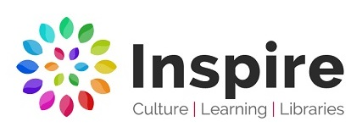
Artist and Author in Residence Brief
Summer Reading Challenge 2024

Who we are:
Inspire: Culture, Learning and Libraries is a charitable community benefit society delivering cultural and learning services across Nottinghamshire.

Our mission is: “To inspire people to read, learn and enjoy culture”.
inspireculture.org.uk

Inspire is a National Portfolio Organisation (NPO) and this opportunity is funded by Arts Council England. Inspire’s NPO funding focuses on the following Libraries:
Arnold, Beeston, Bingham, Hucknall, Kirkby in Ashfield, Mansfield, Newark, Retford, Southwell, Sutton in Ashfield, West Bridgford and Worksop

The Summer Reading Challenge:
Every year, thousands of families all over the country take part in the UK’s biggest reading event for children in libraries and online, produced by the charity The Reading Agency.
readingagency.org.uk

The challenge, aimed at children aged 4 – 11, is to read six library books during the summer holidays to sustain reading ability and enthusiasm in the long summer break.
inspireculture.org.uk/summerreadingchallenge

The 2024 Summer Reading Challenge is a celebration of the creative arts. We’ll be inspiring children to express themselves in creative ways, tap into a world of imagination and storytelling, and – of course – to read!

What we want:
We are looking for a creatively curious visual artist and an author/writer who get excited about a blank page, like to think imaginatively, and enjoy working in collaboration.

The Artist and Author in Residence will:
- Take wide inspiration from the Summer Reading Challenge 2024
- Design a school workshop (numbers to be negotiated) to be delivered in each of the following libraries: Newark, Retford, Southwell and Worksop Library
- The proposed idea should be linked to your professional practice but made simple and deliverable in a class/year group visit to the libraries
- Create work for a summer exhibition in the four libraries with, or inspired by, the work created by the school children
- Deliver the workshop to family audiences over summer 2024 to reach all twelve NPO libraries
- Work collaboratively with Inspire

Our aims are to:
- Engage children and families with the Summer Reading Challenge theme
- Make great artwork
- Create great stories

Our outcomes are to:
- Connect with four Primary Schools
- Connect with Inspire Libraries
- Create an Exhibition

Past projects:
To see examples of how previous artists and authors have approached the project, visit our website, but we are always looking for new ideas and approaches.
inspireculture.org.uk/artistandauthor

The exhibition:
The Summer Reading Challenge 2024 exhibition will take place in Newark, Retford, Southwell and Worksop Library Galleries:
inspireculture.org.uk/galleries

Proposed timeline:
- School workshops – summer term
- Exhibition dates – Saturday 13 July – Sunday 8 September 2024
- Public workshops – summer holidays

Fee:
Minimum £4000 per person, approx 16 days. A breakdown of the total fee will be negotiated once the final delivery method and approach is agreed. Additional budget for travel, materials, access costs and to ensure quality outcome for the exhibition is available.
NB. There will not be additional budget for accommodation.

Application process:
Submissions should be made by 9am on Monday 8 January 2024 to arts@inspireculture.org.uk

We encourage individual or joint applications and are happy to hear from writer- illustrators.

What we need from you:
We want to work with new and/or established artists and authors but would like to see some examples of your work, that will help us know more about your practice, and a CV which includes your experience in delivering workshops with schools and families. We will accept these in any format. This might be:
- Weblinks
- Photos
- Social media account links
- Book titles
- Podcasts
- Something else…?

We are committed to attracting and recruiting diverse candidates and welcome applications from underrepresented groups.

Thank you for taking the time to review this brief.

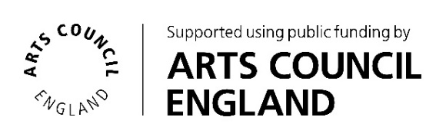
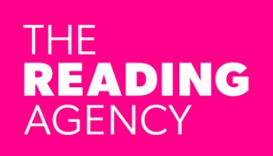
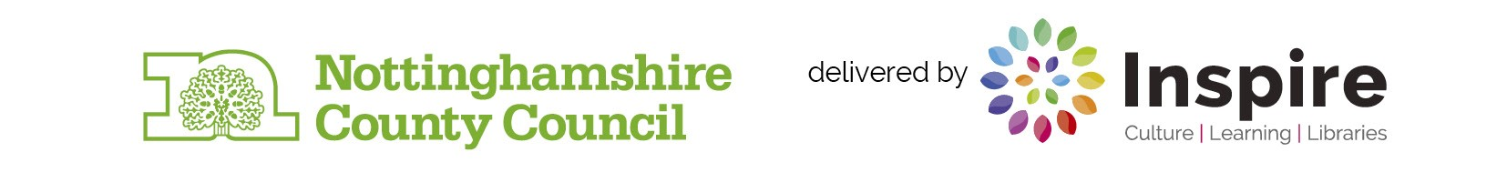
If you require Inspire to make any reasonable adjustments to the process of receiving your ideas and make it more accessible for you, please contact: arts@inspireculture.org.uk

