**Artist Brief: Healthier, Happier, Connected, Creative**

**What is Healthier, Happier, Connected, Creative?**

Inspire: Culture, Learning and Libraries will support the health and wellbeing of older people in 2 places - Hucknall (Ashfield) and Retford (Bassetlaw) - through a 2-year programme of music, visual arts and ageing well interventions in 2 library venues. 48 music concerts will be delivered in partnership with Live Music Now. 48 creative wellbeing workshops will be delivered with commissioned artists. Our health partners will deliver opportunities for socialising, exercise and age-relevant health information. This programme is funded by [Arts Council England](https://www.artscouncil.org.uk/).

Our target groups are:

* People affected by dementia and memory loss
* Their family members and carers
* Older people at risk of social isolation and loneliness

**What we want:**

We are looking for 2 creatively curious artists to deliver the creative wellbeing visual arts workshops in year 1 from May 2025 – April 2026. These artists will:

* Develop their practice by attending paid Continuing Professional Development (CPD)
* Work collaboratively with Inspire, our partners, and other artists on the project
* Engage creatively with our target audiences to co-create original artworks, with a focus on encouraging experimentation using a variety of techniques

**Our aims are to:**

* Support the creative development of artists
* Engage and inspire audiences to explore their creativity
* Foster connection of individuals and communities
* Combat loneliness and improve wellbeing
* Make co-created artworks in a range of artforms
* Create an exhibition

**Our outcomes are to:**

* Build strong and mutually beneficial connections with our target audiences, by delivering collaborative workshops in libraries
* Inspire co-created artwork in any medium
* Create an exhibition showcasing the creative process and selected artworks

**Timeline:**

* CPD and planning opportunities will take place on Thursday 24 April 2025 at West Bridgford Library and on Monday 14 July 2025 online
* Workshop delivery will take place on selected Wednesdays between May 2025 and April 2026
* A library exhibition will be mounted at the end of the project

**Fee:**

* CPD will be paid
* £300 per workshop, this includes expected preparation time
* We expect each artist to deliver 12 half day workshops, one per month – 6 in Retford Library and 6 in Hucknall Library
* Budget for travel, materials, access costs and to ensure quality creative outcomes is available and will be negotiated
* There is no additional budget for accommodation

**Application process:**

Submissions should be made by **9am** on **Monday 14 April** to [arts@inspireculture.org.uk](mailto:arts@inspireculture.org.uk)

**What we need from you:**

1. Your creative response. Below are some prompts to help you think about what you might tell/show us:

* How will you engage the audience?
* What could you do?
* How will you deliver it?
* What will you need?
* How would this improve wellbeing and encourage interpersonal connection?
* What could it produce?

1. Your credentials in the form of past work, and a CV which includes any experience in delivering workshops. We want to work with new and/or established artists but would like to see some examples of your work that will help us know more about your practice. This might be:

* Weblinks
* Photos
* Social media account links
* Published work
* Podcasts
* Something else…?

We will accept any form of application:

* Written (Max one side of A4)
* Audio (Max 2 mins)
* Drawn (Max A2)
* Filmed (Max 2 mins)
* Something else…?

**And finally:**

We are committed to attracting and recruiting diverse candidates and welcome applications from underrepresented groups.

If you require Inspire to make any reasonable adjustments to the process of receiving your ideas and make it more accessible for you, please contact: [arts@inspireculture.org.uk](mailto:arts@inspireculture.org.uk)

Thank you for taking the time to review this brief.

**Further information:**

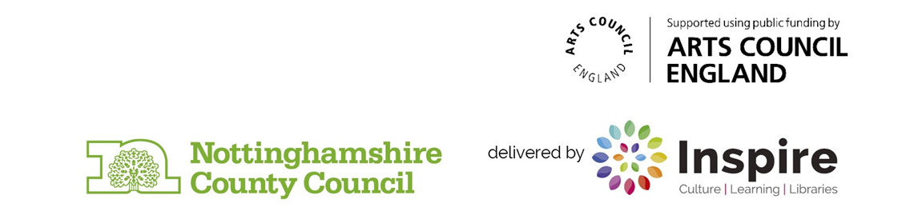[Inspire: Culture, Learning and Libraries](http://Inspireculture.org.uk) is a charitable community benefit society delivering cultural and learning services across Nottinghamshire. Our mission is: “To inspire people to read, learn and enjoy culture”. A close up of a logo
