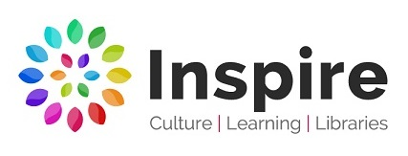
Artist and Author in Residence Brief
Summer Reading Challenge 2026

Who we are:
Inspire: Culture, Learning and Libraries is a charitable community benefit society delivering cultural and learning services across Nottinghamshire.

Our mission is: “To inspire people to read, learn and enjoy culture”.
inspireculture.org.uk

Inspire is a National Portfolio Organisation (NPO) and this opportunity is funded by Arts Council England. Inspire has 58 libraries and 3 mobiles. Inspire’s NPO funding focuses on the following Libraries:
Arnold, Beeston, Bingham, Hucknall, Kirkby in Ashfield, Mansfield Central, Newark, Retford, Southwell, Sutton in Ashfield, West Bridgford and Worksop.

The Summer Reading Challenge:
Every year, thousands of families all over the country take part in the UK’s biggest reading event for children in libraries and online, produced by the charity The Reading Agency.
readingagency.org.uk

The challenge, aimed at children aged 4 – 11, is to sustain reading ability and enthusiasm in the long summer break.
inspireculture.org.uk/summerreadingchallenge

The 2026 Summer Reading Challenge theme will be Read to the Beat: Uniting the magic of stories with the power of music with the detail being released at the end of December.

What we want:
We are looking for a creatively curious visual artist and an author/writer who get excited about a blank page, like to think imaginatively, and enjoy working in collaboration.

The Artist and Author in Residence will:
- Work collaboratively with Inspire.
- Take wide inspiration from the 2026 Summer Reading Challenge to design a workshop linked to your professional practice suitable for primary school children to be delivered in school settings.
  - Deliver the school workshop to 12 of our twinned primary schools across Nottinghamshire.
  - Workshop duration likely to be approximately 1 hour repeated 3 times in a day for 20 to 30 children at a time.
  - Approximately 12 days of delivery, 1 day per school.
- Create content from the resulting schoolwork for exhibition in Beeston library.
- Create a commissioned artwork/writings inspired by the schoolwork for the exhibition.
- Take wide inspiration from the 2026 Summer Reading Challenge to design a workshop linked to your professional practice suitable for family audiences to be delivered in library settings.
- Deliver the family workshops in the 12 libraries named above.
  - Workshops will be bookable, duration likely to be approximately 1-2 hours for 10 to 20 participants (dependent on library space).
  - Approximately 6 days delivery, 2 libraries per day.
- Travel around Nottinghamshire between venues with materials/equipment needed.
- Design an activity for a ‘How to’ sheet suitable for our wider library network.
  - Maximum double side of A4.
  - Printable PDF.
  - Suitable for self-led participation i.e. minimal materials required/no specialist equipment needed.

Inspire will:
- Work collaboratively with the artist and author.
- Contact and contract the primary schools.
- Curate the library exhibitions.
- Programme the public workshops in libraries.
- Manage the bookings for the public workshops.
- Support artist and author to deliver the project.
- Promote activity through Inspire’s Marketing and Communications team/channels.
- Record the project through photography, film and an evaluation process.

Our aims are to:
- Engage children and families with the Summer Reading Challenge theme.
- Make great artwork.
- Create great stories.

Past projects:
To see examples of how previous artists and authors have delivered the project, visit our website, but we are always looking for new ideas and approaches.
inspireculture.org.uk/artistandauthor

Proposed timeline:
- School workshops – Summer term/June 2026
- Exhibition dates – Saturday 11 July – Sunday 6 September 2026
- Public workshops – Nottinghamshire school summer holidays (28/7/26 - 1/9/26)

Fee:
Minimum £4500 per person, approximately 18 delivery days. A breakdown of the total fee will be negotiated once the final delivery method and approach is agreed. Additional budget for workshop preparation, travel, materials, commission, access costs and to ensure quality outcome for the exhibition is available.

NB. There will not be additional budget for accommodation.

Application process:
Submissions should be made by 9am on Friday 5 December 2025 to arts@inspireculture.org.uk

We encourage individual or joint applications and are happy to hear from writer- illustrators.

What we need from you:
We want to work with new and/or established artists and authors but would like to see some examples of your work, that will help us know more about your practice, and a CV which includes your experience in delivering workshops with schools and families. We will accept these in any format. This might be:
- Weblinks
- Photos
- Social media account links
- Book titles
- Podcasts
- Something else…?

We are committed to attracting and recruiting diverse candidates and welcome applications from underrepresented groups.

Thank you for taking the time to review this brief.

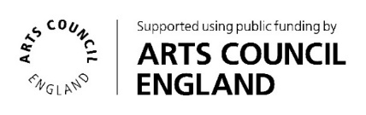
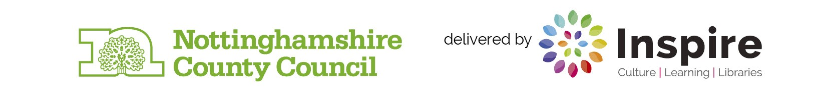
If you require Inspire to make any reasonable adjustments to the process of receiving your ideas and make it more accessible for you, please contact: arts@inspireculture.org.uk

