Artist Brief: I Am A Maker
What is I Am A Maker?
I Am A Maker is the fourth branch of our I Am A Creator cultural programme. I Am A Creator is funded by investment from Arts Council England, through our status as an ACE National Portfolio Organisation. This programme will see us working with libraries across the county and targeted groups in Bassetlaw, Ashfield, Mansfield and Newark & Sherwood.

Our target groups are:
- People affected by dementia
- Older people
- Special Educational Needs and Disabilities (SEND) schools
- Neurodivergent families
- Wider public audiences, including audiences that can be/feel excluded from the arts
What we want:
We are open to creative approaches in any artform. We are looking for five creatively curious makers* to:
- Develop their practice by attending paid Continuing Professional Development (CPD)
- Work collaboratively with Inspire, our partners, and other makers on the project
- Engage creatively with our target audiences to co-create original artworks, and make a commissioned piece

*By maker we mean artists who work creatively with a materials-based practice in either 2D or 3D, for example: clay, metal, paper, wood, glass, willow, textiles

Our aims are to:
- Support the creative development of makers
- Engage and inspire audiences to explore their creativity
- Make great co-created artwork
- Tour the work to Inspire Library Galleries
- Be part of The Big Draw 2026

Our outcomes are to:
- Build strong and mutually beneficial connections with our target audiences, by delivering collaborative workshops in Inspire libraries and community settings
- Inspire co-created artwork
- Inspire commission pieces
- Create an exhibition, publication and podcast

Proposed Timeline:
- CPD and planning opportunities will take place during April and May 2026 (Dementia Awareness Training for the Arts + Access and Inclusivity Training)
- Group workshops delivery will take place between June and September 2026
- Public workshop delivery will take place in October 2026 (The Big Draw Festival month)
- Podcast recordings will take place during October and November 2026
- Publication and podcast released March 2027
- Library exhibition dates:

Worksop Library | Saturday | 03 October 2026 | Sunday | 15 November 2026
Mansfield Central Library | Wednesday | 18 November 2026 | Thursday | 24 December 2026
West Bridgford Library | Wednesday | 6 January 2027 | Sunday | 14 February 2027
Beeston Library | Wednesday | 17 February 2027 | Wednesday | 31 March 2027
inspireculture.org.uk/galleries

Fee:
- CPD workshops will be paid
- Each target group will have 4 (half day) workshops plus introductory meeting
- Each library will have 1 (half day) public workshop
- Fee for commissioned piece to be negotiated

Rate £250 per workshop, this includes expected preparation time. Workshops will be shared between the selected makers. Additional budget for travel, materials, access costs and to ensure a quality creative outcome suitable for exhibition from each group is available and will be negotiated. There is no additional budget for accommodation.

Application process:
Submissions should be made by 9am on Monday 2 March 2026 to arts@inspireculture.org.uk

What we need from you:
- Your creative response. Below are some prompts to help you think about what you might tell/show us:
- How will you engage the audience?
- What could you do?
- How will you deliver it?
- What will you need?
- What could be produced?

- Your credentials in the form of past work. We want to work with new and/or established makers but would like to see some examples of your work that will help us know more about your practice. This might be:
- Weblinks
- Photos
- Social Media account links
- Book titles
- Podcasts
- Something else…?

We will accept any form of application:
- Written (Max one side of A4)
- Audio (Max 2 mins)
- Drawn (Max A2)
- Filmed (Max 2 mins)
- Something else…?

And finally:
We are committed to attracting and recruiting diverse candidates and welcome applications from underrepresented groups. If you require Inspire to make any reasonable adjustments to the process of receiving your ideas and make it more accessible for you, please contact: arts@inspireculture.org.uk

Thank you for taking the time to review this brief.

Further information:
Inspire: Culture, Learning and Libraries is a charitable community benefit society delivering cultural and learning services across Nottinghamshire. Our mission is: “To inspire people to read, learn and enjoy culture”.

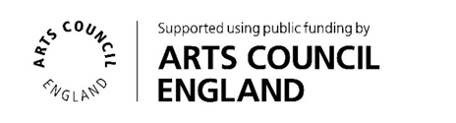
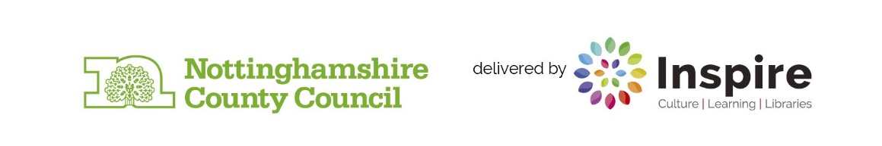
The Big Draw Festival is a worldwide celebration of drawing! The Big Draw promote the universal language of drawing as a tool for learning, expression, and invention. They are the founder force behind The Big Draw Festival, which is a major component of their work in encouraging people to get back to the drawing board! The festival is made up of a collection of thousands of creative events, activities, and workshops across the globe run by organisations big and small, from individuals to entire cities!

