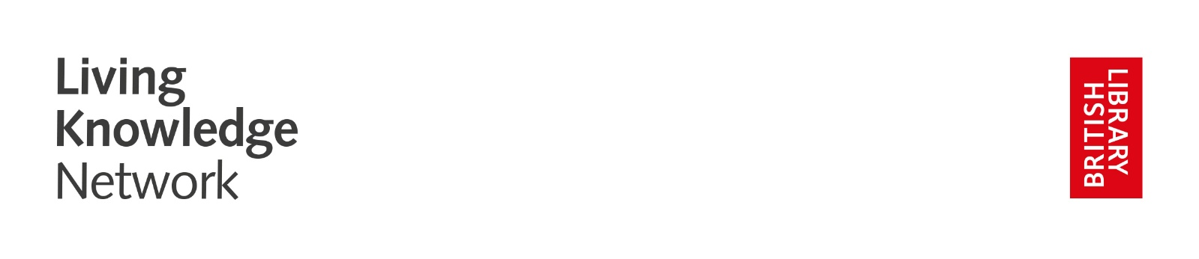
Commission to create an immersive murder mystery drama piece in celebration of the British Library Living Knowledge Network Exhibition Agatha Christie: A World of Mystery

Who we are:

Nottingham City Libraries is operated by Nottingham City Council, delivering the public library service across the city, including the Nottingham Central Library.
nottinghamcitylibraries.co.uk

Inspire: Culture, Learning and Libraries is a charitable community benefit society delivering cultural and learning services across the county of Nottinghamshire. Our mission is: “To inspire people to read, learn and enjoy culture”.
inspireculture.org.uk

We are members of the British Library Living Knowledge Network (LKN). LKN is a UK-wide partnership of national and public libraries. Together we share ideas and spark connections between libraries, their collections and their people.
Created by the British Library to explore new ways for libraries across the country to work as one, the network currently includes over 20 public libraries, the British Library itself, the National Library of Scotland and the National Library of Wales.
The Living Knowledge Network is the only network of its kind in the UK and is centred on exchanging knowledge and developing memorable experiences for public library users, from simultaneous UK-wide exhibitions to leadership and development.
living-knowledge-network.co.uk

Agatha Christie: A World of Mystery Exhibition, touring libraries from 30/10/2026 - 29/06/2027
Delve into the remarkable life and legacy of the bestselling novelist of all time, Agatha Christie, at an exhibition opening at the British Library and Living Knowledge Network partner libraries in October 2026. From her best-loved characters including Hercule Poirot and Miss Marple, to her impact on crime writers today, unravel the secrets behind the Queen of Crime’s enduring appeal.
Events.bl.uk/exhibitions/agathachristie

We are establishing a city/county partnership model across neighbouring library services. The immersive drama commission will reach communities in the following Libraries:
Nottingham Central, Strelley Road, Hyson Green, St Ann’s
Mansfield Central, Kirkby in Ashfield, Sutton in Ashfield, Hucknall.

This opportunity is funded by Arts Council England.

What we want:
We are looking for a creatively curious theatre/drama practitioner(s) who gets excited about creating new work, likes to think imaginatively, and enjoys working in collaboration.

Our aims are to:
- Support and enhance engagement with the national tour of the British Library Living Knowledge Network exhibition: Agatha Christie: A World of Mystery
- Actively engage with young people (KS3+) and families (all ages from 7+)
- Commission an immersive drama piece inspired by Agatha Christie and the notion of “Body in the Library”

The theatre/drama practitioner(s) will:
- Work collaboratively with Nottingham City Libraries and Inspire
- Take inspiration from Agatha Christie to create an immersive drama murder mystery suitable for young people and families to be delivered in library settings
- Deliver the immersive drama murder mystery performance in the 8 libraries named above
  - Performances will be bookable (2 for YP and 6 for families) for 25 people per performance
  - Travel around Nottinghamshire between venues with props and equipment as needed

Nottingham City Libraries and Inspire will:
- Work collaboratively with and support the theatre/drama practitioner(s) to deliver the project
- Engage with family audiences and young people through both the City Cultural Education Partnership (CEP), Challenge and the Ashfield and Mansfield CEP Captivate
- Programme performances in libraries
- Manage communication and bookings for the performances
- Promote the tour through Nottingham City Libraries’ and Inspire’s Marketing
and Communications team/channels
- Record the project through photography, film and an evaluation process
We are always looking for new ideas and approaches.
To see examples of previous programmes relating to The Living Knowledge Network, visit inspireculture.org.uk/LKN

Proposed timeline:
- Development – June 2026 – August 2026
- Performances – 30/10/2026 - 29/06/2027 There will be 1 performance at 8 library venues across the exhibition tour period. Performance dates are to be negotiated and will not be on consecutive days
Fee:
- Immersive drama murder mystery development fee £1000
- 8 performances £450 per performance,
Total fee £4600

NB. No additional budget for travel and accommodation.

Application process:
Submissions should be made by 9am on Monday 1 June 2026 to culture@inspireculture.org.uk

We encourage individual or joint applications.

What we need from you:
- Your creative response!
Tell us how you will use your talents to meet the aims. Below are some prompts to help you think about what you might tell/show us:
- What could you do?
- How will you deliver it?
- What will you need?
- How will it engage our audience?

- We want to work with new and/or established theatre/drama practitioner(s) but would like to see some examples of your work, that will help us know more about your practice, and a CV which includes your experience. We will accept these in any format. This might be:
- Showreels
- Weblinks
- Photos
- Social media account links
- Podcasts
- Something else…?

We will accept any form of application:
- Written (Max one side of A4)
- Audio (Max 2 mins)
- Drawn (Max A2)
- Filmed (Max 2 mins)
- Something else…?

And Finally:
We are committed to attracting and recruiting diverse candidates and welcome applications from underrepresented groups.
If you require us to make any reasonable adjustments to the process of receiving your ideas and make it more accessible for you, please contact: culture@inspireculture.org.uk
Thank you for taking the time to review this brief.
