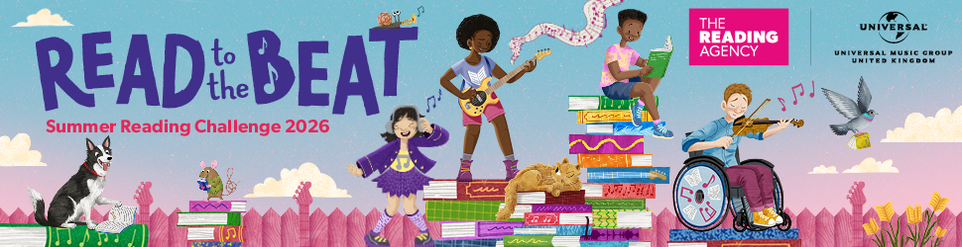
Encourage your pupils to join the FREE Summer Reading Challenge
with Nottinghamshire Inspire Libraries
The Summer Reading Challenge is the UK’s biggest reading for pleasure programme for children aged 4 to 11. Last year nearly 8,000 Nottinghamshire children took part.
Why it matters
Only 1 in 3 children and young people say they enjoy reading, a drop of 33% since 2005 (Clark, et al., 2024). In the National Year of Reading, we’re on a mission to change this and we need your help. We’d love you to encourage your pupils to take part in the Summer Reading Challenge taking place in all Nottinghamshire Libraries (and around the country).
Benefits for your pupils
- Builds reading confidence and independence
- Ensures pupils are ready for their autumn return, preventing the summer reading ‘dip’
- Supports transition between year groups
Ready-to-use resources for schools
We’ve created materials to help promote the challenge including poster, suggested text for newsletters/websites, web graphics and a video introduction to the challenge.
www.inspireculture.org.uk/ReadtotheBeatResources
FREE virtual assembly with author Bethan Woollvin | Tuesday 14 July at 10am.
Hear about the Summer Reading Challenge along with storytelling and a draw along from author and illustrator Bethan Woollvin
How the Summer Reading Challenge works
- Children sign up at any Nottinghamshire Inspire library,
- Set 6 reading goals of their choice
- Earn rewards for every goal achieved.
- Children who complete the Challenge in libraries receive a certificate and a medal.
- Library staff and volunteers are on hand to talk to children about the books they have read.
An online challenge with digital rewards is also available www.summerreadingchallenge.org.uk
Contact: Carolyn Gallagher, Libraries and Culture Officer at carolyn.gallagher@inspireculture.org.uk
The Summer Reading Challenge is produced by The Reading Agency and delivered in partnership with libraries.

