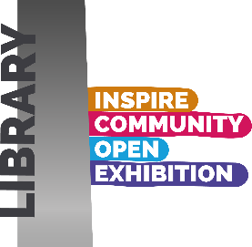
Inspire Community Open Exhibition 2026
Saturday 7th November 2026 until 4pm Saturday 19th December 2026
Please complete all the following
Name: …………………………………………………………………………………………………….
Tel No ………………………………………………….………………………………….……………..
Email: ………………………………………………………………………………………………………
Title of work: ………………………………………………………………………….
please print in block letters as you would like it shown, once submitted this cannot be changed.
Is the work 2D 3D please tick relevant box
Is the piece for sale? Yes No please tick relevant box
Price of work if selling: …………………………………………………………………………………………
Medium used: ……………………………………………………………………………………………….……
I give my permission for Inspire to pass my contact details to any potential buyers.
YES NO Please tick.
I give my permission for Inspire to inform me of any future events
YES NO Please tick.

I have read and agree to the terms and conditions:
Signature ………………………………………………………………………………………………………
Date………………………………………………………………………………………………………………
__________________________________________________________
Sign artwork in…………………………………. Date………………………………………

Sign artwork out………………………………. Date……………………………………….

Staff use only: £5.00 entry paid - please initial.

