
Book Babies: Call out for Early Years Creatives

Who we are:
Inspire: Culture, Learning and Libraries is a charitable community benefit society delivering cultural and learning services across Nottinghamshire. Our mission is: “To inspire people to read, learn and enjoy culture”.

Our website is inspireculture.org.uk

What is Book Babies?
Book Babies (working title) is one strand of Inspire’s Baby Steps to Reading Wellbeing programme. Supported using public funding by the National Lottery through Arts Council England, the programme will see us working with parents and babies (aged 0–3) in libraries and Family Hubs in Ashfield and Mansfield.
What we want:
We are looking for two creative practitioners with experience of working with early years children (aged 0-3) and a passion for books and reading, to design and deliver playful and creative book-based sessions in libraries and Family Hubs for parents and their babies.
The sessions should nurture a love of books, stories and shared reading, through creative and interactive experiences, for both the child and parent.
Sessions will take place in Kirkby-in-Ashfield Library and Mansfield Central Library, and in Family Hubs in those areas. Continuing Professional Development (CPD) and planning opportunities will take place during October 2026.
Our aims for Book Babies are to:
- nurture enjoyment and confidence of sharing books between parent and child
- allow parents space to explore how their baby responds to books
- support the creative development of our practitioners
- deliver excellent and inspiring book-based sessions for parents and babies that can inform how we develop our current library offer

Timeline overview:
- CPD and planning opportunities will take place during October 2026
- Session delivery will take place across two programme cycles, the first between November 2026 & March 2027, and the second between April and July 2027
- Practitioners will deliver eight sessions in each programme cycle

Our practitioners will:
- Work collaboratively with Inspire and our project partners
- Attend CPD
- Take wide inspiration from the CPD, and their own practice, to design playful and creative book-based sessions suitable for parents and babies in community and library settings
- Travel between venues with any materials and equipment needed
- Contribute to the project’s evaluation by recording feedback from sessions and reporting their own experiences

Inspire will:
- Work collaboratively and support the creative development of the practitioners
- Support the delivery of CPD via our partners at Nottingham Trent University
- Programme the sessions in libraries and Family Hubs
- Manage session booking
- Support practitioners to deliver the project
- Promote through our central communications and marketing team
- Record the project through photography, illustration and evaluation processes
- Design, develop and record the creative outcomes through legacy materials

Fees available:
- £275 per Book Babies session, inclusive of preparation, team liaison and delivery (Estimate of 16 sessions per practitioner)
- Attendance at CPD and a planning session will be paid
- £250 travel allowance
- There is some additional budget available for materials
All fees are inclusive of VAT where applicable. There is no budget for accommodation.
Application Process
What we need from you:
- A short outline to describe how you might creatively approach a Book Babies session.

Below are some prompts to help you think about what you might tell/show us:
- How might you engage the audience?
- What could you do?
- How might you deliver it?

We will accept this is any format. This might be:
- Written (Max one side of A4)
- Audio (Max 2 mins)
- Filmed (Max 2 mins)
- Something else…?

- We would also like to see some examples of your work, that will help us know more about your practice, and a CV which includes your relevant experience working with early years children and their families.
We will accept these in any format. This might be:
- Weblinks
- Photos
- Social media account links
- Podcasts
- Something else…?

We are committed to attracting and recruiting diverse candidates and welcome applications from underrepresented groups.
Closing date for submissions
Submissions should be made by Monday 24 August to reading@inspireculture.org.uk
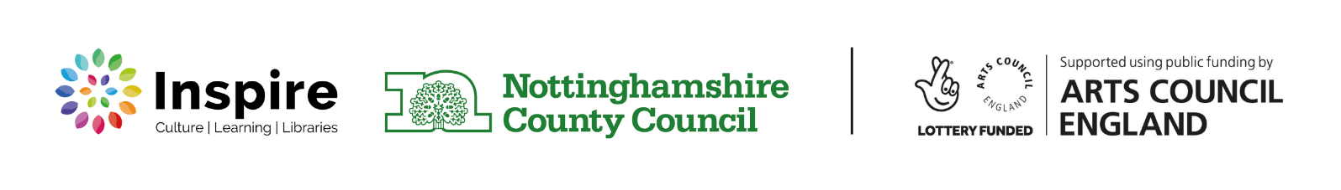
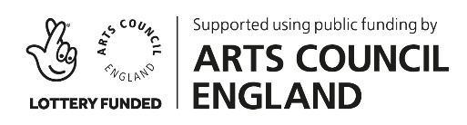
Please contact us at reading@inspireculture.org.uk if you have any questions or need us to make any adjustments for receiving your ideas.
Thank you for taking the time to review this brief.

