
Baby Steps to Reading Wellbeing: Call out for Evaluation Partner

Who we are:
Inspire: Culture, Learning and Libraries is a charitable community benefit society delivering cultural and learning services across Nottinghamshire. Our mission is: “To inspire people to read, learn and enjoy culture”. Our website is inspireculture.org.uk

What is Baby Steps to Reading Wellbeing?
Baby Steps to Reading Wellbeing is a new programme from Inspire that aims to support adult confidence in sharing books with their very young children and provides accessible reading initiatives for time-poor parents to connect with reading for their own wellbeing. Supported using public funding by the National Lottery through Arts Council England, the programme will see us working with parents and babies (aged 0–3) in libraries and Family Hubs in Ashfield and Mansfield.
What we want:
We are looking for an Evaluation Partner with experience of working across an extended, phased project. The programme will take a “test and learn” approach and be shaped by participant feedback throughout. We want the work to inform reading programmes beyond the project, so you will develop appropriate, accessible and targeted evaluation methods within the framework of the COM-B Model of Behaviour Change (i.e. behaviour change needs capability, opportunity and motivation). We want to ensure our activity addresses common barriers to reading and reading confidence.
You will devise light-touch mechanisms to survey attitudes to reading, reading frequency, and explore the impact our programmes have on reading enjoyment and the desire to read more, recognising that motivation to read is a first step to accessing its wellbeing impacts.
Your evaluative work will take place alongside creative practitioners with a passion for books and reading, who will design and deliver playful and creative book-based sessions in libraries and Family Hubs for parents and their early years children (aged 0-3). The evaluation will also cover a programme of events designed for parents to explore their own reading, which may be led by authors or storytellers.
We will be using a Visual Note-taker to document our whole project. Their observations will feed into your final report which will be shared with sector and project partners including parents and library staff. Both the final report and the visual recording will contribute to the creation of legacy materials, created for sharing with Inspire colleagues and more widely with other library services across the country.
Sessions will take place in Kirkby-in-Ashfield Library and Mansfield Central Library, and in Family Hubs in those areas. Session dates will be negotiated as the project takes shape. This work may include a combination of desk research and in-person contact with participants and partners.
Project timeline overview:
- Initial planning with Evaluation Partner will take place September/October 2026.
- Book Babies session delivery will take place between November 2026 and July 2027.
- Parent-focused events will take place between December 2026 and November 2027.
- Final Evaluation Report will be produced by 31 January 2028.

Scope of work:
- Work collaboratively with Inspire and our project partners and practitioners.
- Collate, analyse and present published data and intelligence covering local demographics, early-years reading and parent reading for pleasure to contextualise this project.
- Devise and implement effective qualitative and quantitive evaluation methods alongside Inspire’s Libraries & Culture staff.
- Negotiate with flexibility to attend a range of events in a variety of venues across Ashfield and Mansfield Districts.
- Consider information and observations from partners and stakeholders, including participants, library and Family Hub staff.

Outcomes:
- Regular summary of findings marking each project phase to inform practice for up-coming phases.
- A full final report analysing the project’s context, aims, basis, methodology, practical delivery and impact, making recommendations for future practice.

Inspire will:
- Work collaboratively with the Evaluation Partner.
- Provide the Evaluation Partner with a bank of existing, relevant, up-to-date research reports about early-years and parent reading.
- Gather data measuring bookings and attendance.
- Encourage our creative practitioners and session leaders to record informal feedback from sessions.
- Record the overall project through visual notes, photography, video and other evidencing processes.

Timeframe for submissions:
- Deadline for seeking clarifications on brief: Friday 4 September 2026. Please email reading@inspireculture.org.uk
- Deadline for submission: Sunday 13 September 2026
- Delivery period: October 2026 – February 2028
Fee
Maximum £6000 (inclusive of VAT and all costs). There will not be additional budget for travel or accommodation.
Application Process
What we need from you:
- A short proposal outlining how you will approach this work and deliver the intended outcome within the required timescale.

- Please include a CV or other document which details your experience and relevant competencies to undertake the work and two referees who could support your suitability to work on this project.

We are committed to attracting and recruiting diverse candidates and welcome applications from underrepresented groups. Please contact us at reading@inspireculture.org.uk if you have any questions or need us to make any adjustments for receiving your ideas.
Closing date for submissions
Submissions should be made by Sunday 13 September 2026 to reading@inspireculture.org.uk
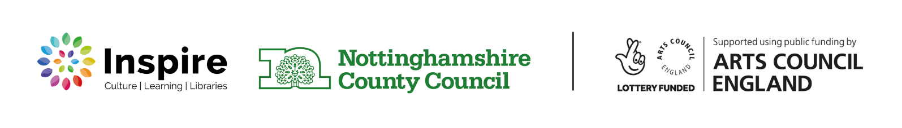
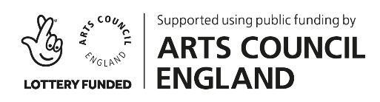
Thank you for taking the time to review this brief.

