
2026 West Mobile Route Gotham

Every second Monday except Bank Holidays
Location: Opposite the Sun Inn within the Square Gotham NG11 0HX
Opening hours 10.15 to 13.15

12th January | 26^{h} January | 09th February | 23rd February
09thMarch | 23rd March | 06th April  Closed Easter Monday | 20thApril
04th May closed.  May Day | 18th May | 01st June | 15^{h} June
29thJune | 13th July | 27th July | 10th August
24thAugust | 07thSeptember | 21st September | 05th October
19th October | 02nd November | 16th November | 30thNovember
14th December | 11th January 2027

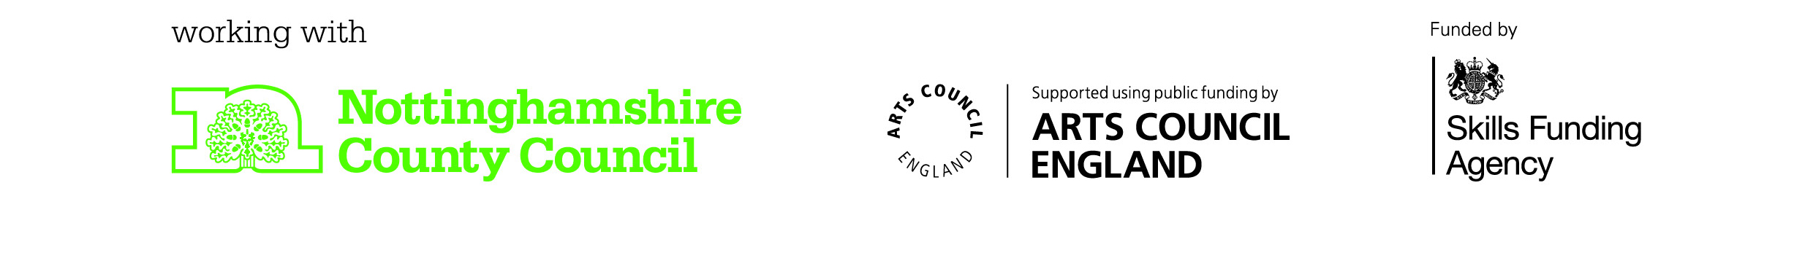

For information about requested titles or items of stock, please contact: Kirkby Library Tel No: 01623 677200 E-mail kirkby.library@inspireculture.org.uk

